Management of Surgical Constipation in Children
Abstract
Background: Constipation is a common pediatric concern, affecting up to 30% of children and often resulting in significant healthcare visits. Chronic constipation can be functional or surgical, with conditions like Hirschsprung disease, anorectal malformations, and dolichocolon (DC) contributing to the surgical subset. This study aims to distinguish chronic surgical constipation from habitual constipation and to assess the management approaches.
Methods: A prospective interventional study was conducted at Benha University Hospital from August 2023 to September 2024, including 60 pediatric patients diagnosed with surgical constipation (Hirschsprung disease, DC, or anorectal malformation). Comprehensive evaluations included clinical history, physical examinations, laboratory tests, radiological imaging, and pathological assessments. Surgical management involved various techniques, and postoperative outcomes were monitored.
Results: The cohort's median age at diagnosis was 7 years, with a predominance of females (60%). Hirschsprung disease was the most common surgical cause (60%). Surgical interventions included anoplasty (26.7%), sigmoidectomy (13.3%), and Swenson procedure (40%). The mean operative time was 3 hours. Postoperatively, the mean length of hospital stay was 9 days, with a 20% readmission rate. Notably, 20% experienced anastomosis dehiscence. Recurrence was observed in 13.3%, with 33.3% requiring long-term laxatives. Significant differences in outcomes, such as surgical procedure type and operative time, were found between patients requiring additional interventions and those without.
Conclusion: Chronic surgical constipation in children presents with varied symptoms and requires tailored surgical interventions. Timely diagnosis and appropriate surgical management can improve outcomes, but recurrence remains a concern. Further investigation into long-term management strategies is warranted.
Keywords: Pediatric Constipation, Hirschsprung Disease, Dolichocolon, Surgical Intervention, Postoperative Outcomes.
Introduction
Constipation is a prevalent issue in childhood, affecting up to 30% of children and accounting for 10% of pediatric outpatient visits and 25% of referrals to pediatric surgery clinics (1). Its presentation can vary, with common symptoms including infrequent stool, pain, soiling, stool withholding behaviours, blood in stool, enuresis, and other urinary symptoms (2).
The etiology of constipation can be functional or organic. Functional constipation often results from a history of painful stooling, leading to withholding behaviors and prolonged fecal stasis. This causes fluid resorption from the stool in the colon, resulting in large, hard stools and rectal dilation. With rectal dilation, a larger stool burden is required to activate rectal stretch receptors, causing patients to lose the urge to defecate. Organic causes of constipation include physiological, neuromuscular, metabolic/endocrine, and anatomic factors such as anterior displaced anus, anal stenosis, and vestibular anus (3).
Constipation is diagnosed through a thorough history and clinical examination. The history should include a detailed review of symptoms, potential precipitants, and "red flags" to rule out organic pathology, such as failure to thrive, delayed passage of meconium, abnormal bowel habits since birth, and changes in bowel patterns with the introduction of cow's milk. Physical examination involves abdominal, perineal, and rectal assessments, which help identify anorectal anatomical issues, Hirschsprung's disease, and provide valuable information on sphincter tone and rectal loading (4).
Dolichocolon (DC) is an anatomical variant marked by abnormal elongation and redundancy of the colon, which can occur in the right, middle, and left sections, as well as at the flexures. Its exact prevalence is unknown. Hirschsprung's disease, a congenital condition characterized by the absence of ganglion cells in the rectum and distal colon, leads to constipation. Classic presentations include delayed passage of meconium, progressive constipation, abdominal distention, and complications such as enterocolitis and failure to thrive (5).
Recommended investigations to confirm the diagnosis of constipation include laboratory tests, radiological studies, manometric studies, and pathological examination. Once diagnosed, treatment can proceed accordingly. Anterior displacement of the anus requires anorectoplasty, while immediate surgery is recommended for DC if a sigmoid loop is twisted. In Hirschsprung's disease, surgical treatment involves excising the aganglionic segment and performing an anastomosis between the normal proximal colon and anal canal. The most recent approach is the one-stage transanal endorectal pull-through, where the colon is excised through the anal canal without an abdominal incision or colostomy (6).
Therefore, we conducted this study to distinguish chronic surgical constipation from habitual constipation in children and how to deal with.
Patients and Method
Study design and population
This prospective interventional study was conducted on 60 pediatric patients with surgical causes of constipation, at the Pediatric Surgery Unit of General Surgery Department at Benha University Hospital from August 2023 to September 2024. The study received approval from the Institutional Review Board (IRB), Faculty of Medicine, Benha University (Approval code: MS 33-7-2023). All participants’ caregivers provided informed consent.
Inclusion criteria for the study were patients aged 0 to 18 years, of both sexes, diagnosed with Hirschsprung disease, DC, or anorectal malformation. The exclusion criteria for the study include patients with constipation due to physiological or habitual causes, those with significant psychiatric comorbidities, and individuals with a recent history of blood transfusion, infection, or trauma.
Assessments
All patients underwent data collection, including a thorough history, clinical examination, and laboratory investigations. A Full history taking covered details such as age, sex, age at onset of defecation issues, and symptoms like abnormal bowel habits, failure to thrive, delayed meconium passage, and changes in bowel habits with cow’s milk. Additional symptoms, prior drug exposure, congenital anomalies, medical conditions, and previous surgeries were also documented.
Clinical examination involved general assessment of vital signs and neurological evaluation, along with local examination of the abdomen for distension, tenderness, and visible peristalsis. Rectal examination was performed to assess anorectal issues. Laboratory investigations included complete blood count, serum electrolytes, thyroid function tests, urine and stool analysis, renal and liver function tests to evaluate for organic causes of constipation.
Radiological investigations included plain X-ray of the abdomen, abdominal sonography, and gastrograffin enema. Bijoś et al. described using ultrasound to diagnose constipation, noting that the transverse diameter of the rectal ampulla increases with age, influencing measurements. The recto-pelvic ratio, the width of the rectal ampulla to the distance between the anterior superior iliac spines, is used to define 'megarectum' (7). Gastrograffin enema helps in diagnosing Hirschsprung disease, where a change in colonic diameter from a narrow aganglionic segment to a dilated ganglionic segment is characteristic, though definitive diagnosis requires histologic confirmation (8). Pathological examination involved rectal biopsy.
Managements
Surgical management included anoplasty, sigmoidectomy, and both the Soave and Swenson procedures, performed either via open or laparoscopic techniques. Intraoperative complications, such as bleeding and soiling, were also assessed.
The management of functional constipation (FC) begins with non-pharmacological interventions, including proper fiber and fluid intake, regular physical activity, and toilet training for children with a developmental age of at least four years, as per ESPGHAN/NASPGHAN guidelines (9). Education is vital, helping alleviate anxiety and improve treatment adherence by explaining FC pathophysiology and the variability in progress. Behavioral therapies focus on regularizing toilet routines and improving defecation dynamics. While increased fiber intake can reduce constipation risk, excessive fiber has limited therapeutic value. Biofeedback training may help select cases, but its effectiveness in young children remains uncertain (10). If non-pharmacological methods fail, pharmacological treatments include disimpaction with high-dose polyethylene glycol (PEG) and maintenance therapy with PEG or lactulose, followed by gradual weaning (11, 12).

Follow-up and outcomes
Postoperative follow-up includes assessing the length of hospital stay, readmission rates, and immediate complications such as anastomosis dehiscence and infection. Outcomes measurement focuses on time to first bowel movement, stool consistency, stool frequency, bowel incontinence, and the need for additional interventions. Long-term outcomes are evaluated by the continued need for laxatives, enemas, and the occurrence of recurrence.
Sample size
OpenEpi, Version 3, open-source calculator-clinical trial was used to calculate the least required sample size at 0.05 alpha error, power of 0.80 and percent of exposed with outcome is 60%. The least number is 24 patients. Allowing drop out or missed data and to increase validity of the study results, the sample size were adjusted and increased to 60.
Statistical analysis
Data management and statistical analysis were done using SPSS version 28 (IBM, Armonk, New York, United States). Quantitative data were assessed for normality using the Shapiro-Wilk test and direct data visualization methods. According to normality, quantitative data were summarized as means and standard deviations or medians and ranges. Categorical data were summarized as numbers and percentages. Quantitative data were compared according to the need for additional procedure or recurrence using the independent t-test or Mann-Whitney U test for normally and non-normally distributed quantitative variables, respectively. Categorical data were compared using the Chi-square or Fisher’s exact test. All statistical tests were two-sided. P values less than 0.05 were considered significant.
Results
The median age at diagnosis of patients was 7 years, with a range from 7 days to 15 years, and the cohort consisted of 40% males and 60% females. Thirteen point three percent of patients had associated congenital anomalies, with the primary surgical causes being Hirschsprung disease (60%), aganglionosis (60%), anorectal malformation (26.7%), and DC (13.3%). The mean stenosis length was 3 cm (SD 1 cm). Symptom frequency revealed 45.5% experienced symptoms every two weeks, 36.4% every three weeks, and 18.2% weekly, with abdominal distension being the most common symptom (73.3%), followed by abdominal pain (40%) and vomiting (20%). Prior treatments were documented in 46.7% of patients. Surgical interventions included anoplasty (26.7%), sigmoidectomy (13.3%), Soave procedure (20%), and Swenson procedure (40%), with 86.7% undergoing open surgery and 13.3% laparoscopic. The mean operative time was 3 hours (SD 1 hour), and intraoperative complications included bleeding (13.3%) and soiling (20%), while 66.7% had no complications. The mean length of stay was 9 days (SD 4), with a 20% readmission rate. Postoperative complications included anastomosis dehiscence (20%) and infection (13.3%), but 66.7% had no complications. The mean time to the first bowel movement was 45 hours (SD 17). Regarding stool consistency, 26.7% had liquid stools, 20% semi-solid, and 53.3% well-formed stools. Stool frequency varied, with 40% having daily bowel movements and 13.3% twice daily. Bowel incontinence was reported in 13.3%, and 20% required additional interventions. Long-term outcomes showed 33.3% of patients needed laxatives and 6.7% required enemas, with a recurrence rate of 13.3%. Table 1
Patients requiring further intervention had a higher median age at diagnosis (13 years) compared to those who did not (6 years) (P < 0.001). Surgical causes differed significantly between groups, with none of the intervention group having anorectal malformation, while 33.3% of the non-intervention group did (P = 0.007). All patients in the intervention group had Hirschsprung disease and aganglionosis, compared to 50% in the non-intervention group (P = 0.002). The mean stenosis length was greater in the intervention group (4 cm vs. 3 cm) (P < 0.001). Patients in the intervention group experienced more frequent symptoms, with 66.7% having symptoms every two weeks and 66.7% reporting abdominal pain (P = 0.008, P = 0.035), while all in this group had abdominal distension (P = 0.02). Surgical type was associated with the need for intervention, with none of the intervention group undergoing anoplasty, and most patients underwent open surgery (P < 0.001). The mean operative time was longer for the intervention group (4 hours vs. 3 hours) (P = 0.044), and intraoperative complications, such as soiling, were more frequent (66.7% vs. 8.3%) (P < 0.001). Patients requiring further intervention had a longer mean length of stay (12 days vs. 8 days) and higher readmission rates (66.7% vs. 8.3%) (P < 0.001). Immediate postoperative complications were more severe in the intervention group, with 100% experiencing anastomosis dehiscence (P < 0.001). Additionally, the time to the first bowel movement was significantly longer for the intervention group (64 hours vs. 40 hours) (P < 0.001). Table 2
The surgical cause of anorectal malformation was significantly associated with recurrence (P = 0.005), with 50% of the recurrence group having DC compared to 7.7% in the non-recurrence group. The mean stenosis length was also significantly greater in the recurrence group (5 cm vs. 3 cm) (P < 0.001). Bowel frequency was higher in the recurrence group, with 100% experiencing symptoms every two weeks compared to 33.3% in the non-recurrence group (P = 0.002). Additionally, abdominal pain, vomiting, and previous treatment were significantly more common in the recurrence group (P < 0.001, P = 0.024, P = 0.001). The type of surgery and surgical approach were significantly associated with recurrence, with 50% of recurrence patients undergoing sigmoidectomy and Soave procedure, and 50% receiving laparoscopic surgery (P < 0.001, P = 0.001). Operative time was longer in the recurrence group (5 hours vs. 3 hours) (P < 0.001). Intraoperative complications were borderline significantly associated with recurrence (P = 0.056), and anastomosis dehiscence was more common in the recurrence group (50% vs. 15.4%) (P = 0.056). The length of stay and time to the first bowel movement were similar between groups (P = 0.765 and 0.703, respectively). Table 3
Case presentation
Case 1 represents a 13 years old female patient presented with progressive constipation and history of delayed passage of meconium since birth. Investigations were done and diagnosed with Hirschsprung disease and prepared for surgery. Figure 1
Case 2 represents a 12 years old male patient presented with progressive constipation and abdominal distention. Investigations were done and diagnosed with DC and prepared for surgery. Figure 2, Figure 3
Discussion
Constipation affects up to 30% of children, contributing significantly to pediatric outpatient and surgical referrals (1). Symptoms include infrequent stool, painful defecation, and stool withholding (2). Functional constipation often follows painful stooling, leading to fecal retention and rectal dilation, while organic causes include anatomical or neuromuscular abnormalities like Hirschsprung's disease (3). Diagnosis involves history-taking and physical exams, focusing on "red flags" like delayed meconium passage or failure to thrive (4).
Surgical causes such as DC and Hirschsprung's disease require imaging, manometry, and pathological evaluation. Treatments vary, from anorectoplasty for anatomical issues to resection for Hirschsprung’s, with modern techniques like transanal pull-through reducing invasiveness (6). This study explores the diagnosis and management of surgical constipation in children.
This study found a median diagnosis age of 7 years, with a higher prevalence among females and primary surgical causes including Hirschsprung's disease, aganglionosis, anorectal malformations, and DC. In comparison, a study identified risk factors for postoperative complications in Hirschsprung's disease, observing a male predominance and surgeries performed predominantly after three months of age (13). Additionally, some authors reported a median age of 8 years among older children with constipation, with a larger proportion of male participants (14).
This study reported varied symptom frequency, with abdominal distension as the most common symptom, followed by abdominal pain and vomiting. Nearly half of the patients had received prior treatment. Similarly, certain investigators noted low defecation frequency, common encopresis, and symptoms such as large stools, abdominal pain, and painful defecation. They also highlighted a potential genetic link with a positive family history in some cases (14).
Constipation in children is commonly linked to dietary and lifestyle changes, such as transitioning to solid foods, toilet training, or changes in routine, but chronic cases may suggest underlying conditions like medication effects, low fiber intake, or irritable bowel syndrome. Symptoms include infrequent bowel movements, stool leakage, withholding behaviors, painful defecation, hard stools, bloating, and intermittent abdominal pain relieved by bowel movements (15).
This study evaluated various surgical procedures for treating pediatric constipation, including anoplasty, sigmoidectomy, Soave, and Swenson procedures, with most performed openly and a minority laparoscopically. Outcomes indicated postoperative improvement, with most patients experiencing no complications or requiring additional interventions. Surgical approaches depend on preoperative assessments, coexisting conditions, and surgical team expertise (16, 17). Minimally invasive techniques like laparoscopic and robotic-assisted surgeries have gained favor for reducing pain, hospital stays, and complications (18-20). Advances in surgical techniques have further improved outcomes by reducing operation time, blood loss, and hospital stays while minimizing complications (21, 22).
In this study, postoperative management included laxative use in a third of patients and enemas in a small proportion, with a symptom recurrence rate of 13.3%. A few experts reported long-term improvements in children with functional constipation, with clinical success rates increasing over time, reaching stability after 10 years, and only a small percentage continuing laxative treatment (23).
In this study, patients requiring further intervention were older and had greater stenosis lengths compared to those who did not, with none having anorectal malformations. Delayed diagnosis of constipation in younger children, often due to misattributed symptoms, can lead to complications necessitating surgery as awareness grows with age. Conditions such as Hirschsprung disease, characterized by the congenital absence of nerve cells in the intestines, and anal stenosis, marked by an improperly functioning anal opening, often require surgical correction to address severe symptoms and functional impairments (24-26).
In this study, the intervention group exhibited higher symptom frequency, with more reports of abdominal pain and distension compared to the non-intervention group, suggesting more severe or chronic conditions contributing to constipation. These symptoms, including abdominal pain and distension, are often linked to underlying gastrointestinal issues such as Hirschsprung disease or severe constipation, which may require surgical intervention. Abdominal distension, commonly associated with stool impaction or anatomical abnormalities like stenosis, further indicates the severity of the condition, leading to greater discomfort and potential complications (27-29).
In this study, the type of surgery was a significant factor in determining the need for further intervention, with patients who underwent Soave procedures requiring more follow-up. Anoplasty, which is used to correct anorectal malformations and restore normal bowel function, was absent in the intervention group, highlighting its potential to reduce the need for further interventions in less severe cases (30). The Soave procedure, used for Hirschsprung disease, resects the aganglionic segment and has shown benefits in alleviating constipation and improving bowel motility, though some patients may need additional interventions (31). Similarly, the Swenson procedure, another option for Hirschsprung disease, effectively restores bowel function but may require follow-up care due to potential complications postoperatively (32).
Patients requiring further intervention experienced longer hospital stays and higher readmission rates, along with more severe immediate complications, including anastomosis dehiscence, which was absent in the non-intervention group. Delays in the first bowel movement were also observed in the intervention group. The increased complexity of constipation and related conditions often results in longer operative times, more postoperative complications, and a need for more intensive care, contributing to extended recovery periods (33). Anastomosis dehiscence, caused by factors like surgical tension or inadequate blood supply, was more common in the intervention group, indicating a higher risk of complications (34). Additionally, surgical trauma and postoperative ileus can delay bowel function recovery, requiring careful monitoring (35). In contrast, some authors found no significant differences in certain factors like gender or hemoglobin levels between patients with and without postoperative complications, although differences were seen in clinical classification and surgical methods (13).
In our study, recurrence was significantly associated with anorectal malformation, and DC was more common in recurrence cases, with longer stenosis lengths also observed in these patients. Recurrence was linked to higher bowel frequency, universal abdominal pain, and higher prior treatment rates compared to non-recurrence cases. Experts identified male sex, longer symptom duration, and higher episodes of encopresis as factors influencing relapse risk, while older age at onset was associated with better treatment success. A positive family history had minimal impact on outcomes (14). In line with previous studies, the recurrence of constipation in children can occur in about 50% of cases, with a 48% recovery rate at five years, and early symptom onset, family history, and prior trauma are linked to poorer prognoses (36, 37). Anorectal malformations and DC can complicate bowel function and surgical outcomes, while longer stenosis lengths can impair bowel function and increase recurrence risks (38, 39).
The type of surgery was significantly associated with recurrence, as a higher proportion of recurrence patients underwent sigmoidectomy and the Soave procedure, with more laparoscopic surgeries also performed in this group. Operative times were longer in recurrence cases, reflecting the complexity of the surgeries. Intraoperative complications, including anastomosis dehiscence, were borderline significantly linked to recurrence, although length of stay and time to first bowel movement did not differ significantly between groups. Longer operative times and complications, both intraoperative and postoperative, are often associated with more complex surgeries, which can increase recurrence risks (40). Immediate postoperative complications like fecal soiling and diarrhea are common but typically resolve over time, while long-term issues may include anastomotic stricture and residual aganglionosis (41-44). The higher incidence of complications suggests that more complex surgeries and challenging anatomical conditions increase the likelihood of recurrence (45).
The study has some limitations as it was conducted at a single center with a small sample size, may limit the generalizability and statistical power of its findings. Additionally, the absence of long-term outcome data restricts the ability to evaluate recurrence over time, while operator dependency in some diagnostic and surgical procedures could have introduced variability.
Conclusion
Hirschsprung disease and aganglionosis are the primary surgical causes of constipation in children, with significant associations between age at diagnosis, stenosis length, and the need for additional interventions. The frequency of symptoms and specific surgical approaches, such as the Soave procedure, are associated with increased recurrence and complications.

References
1. Rinebold EA, Lee EJ, Zaniewska K, Cunningham KN, Velcek F. A rare case of cecal volvulus in a pediatric patient with dolichocolon. Journal of Pediatric Surgery Case Reports. 2022;83:102340.
2. Raimondo D, Mattioli G, Casadio P, Borghese G, Ambrosio M, Arena A, et al. Frequency and clinical impact of Dolichocolon in women submitted to surgery for rectosigmoid endometriosis. Journal of Gynecology Obstetrics and Human Reproduction. 2020;49:101697.
3. Gielen L, Raaijmakers A, De Groote B, Ter Haar E. Dolichocolon presenting with bilateral hydronephrosis in a neonate. Case Reports in Pediatrics. 2021;2021:6658525.
4. Raahave D. Dolichocolon revisited: An inborn anatomic variant with redundancies causing constipation and volvulus. World J Gastrointest Surg. 2018;10:6-12.
5. Bolia R, Kumar Bhat N. Redundant colon and refractory constipation in children. Indian J Gastroenterol. 2020;39:521-2.
6. Gomes D, Morais MB. GUT MICROBIOTA AND THE USE OF PROBIOTICS IN CONSTIPATION IN CHILDREN AND ADOLESCENTS: SYSTEMATIC REVIEW. Rev Paul Pediatr. 2020;38:e2018123.
7. Bijoś A, Czerwionka-Szaflarska M, Mazur A, Romañczuk W. The usefulness of ultrasound examination of the bowel as a method of assessment of functional chronic constipation in children. Pediatr Radiol. 2007;37:1247-52.
8. Yan J, Sun J, Wu R, Tan SS, Chen Y, Peng Y, et al. Barium enema findings in total colonic aganglionosis: a single-center, retrospective study. BMC Pediatr. 2020;20:499.
9. Younis AM, Abdellatif MAA, Ali MA, Ali MAE-H, El-Ebidi AM, Maklad SMA, et al. Effect of Tadalafil on Penile Duplex parameters in Erectile Dysfunction Patients. SVU-International Journal of Medical Sciences. 2023;6:249-55.
10. Hite M, Curran T. Biofeedback for Pelvic Floor Disorders. Clin Colon Rectal Surg. 2021;34:56-61.
11. de Geus A, Koppen IJN, Flint RB, Benninga MA, Tabbers MM. An Update of Pharmacological Management in Children with Functional Constipation. Paediatr Drugs. 2023;25:343-58.
12. Fedele F, Fioretti MT, Scarpato E, Martinelli M, Strisciuglio C, Miele E. The ten "hard" questions in pediatric functional constipation. Ital J Pediatr. 2024;50:64.
13. Gao T, Xu W, Sheng Q, Xu T, Wu W, Lv Z. Clinical outcomes and risk factors for postoperative complications in children with Hirschsprung's disease. Am J Transl Res. 2022;14:4830-7.
14. van Ginkel R, Reitsma JB, Büller HA, van Wijk MP, Taminiau JA, Benninga MA. Childhood constipation: longitudinal follow-up beyond puberty. Gastroenterology. 2003;125:357-63.
15. Mulhem E, Khondoker F, Kandiah S. Constipation in children and adolescents: evaluation and treatment. American family physician. 2022;105:469-78.
16. Cheng LS, Goldstein AM. Surgical Management of Idiopathic Constipation in Pediatric Patients. Clin Colon Rectal Surg. 2018;31:89-98.
17. Koppen IJ, Kuizenga-Wessel S, Lu PL, Benninga MA, Di Lorenzo C, Lane VA, et al. Surgical decision-making in the management of children with intractable functional constipation: What are we doing and are we doing it right? J Pediatr Surg. 2016;51:1607-12.
18. Menon R, Saxena R, Sinha A, Nayak S, Jadhav A, Rathod K, et al. Retrospective analysis of laparoscopically managed pediatric patients with Hirschsprung disease. Journal of Pediatric Endoscopic Surgery. 2022;4:149-55.
19. Delgado-Miguel C, Camps JI. Robotic Soave pull-through procedure for Hirschsprung's disease in children under 12-months: long-term outcomes. Pediatr Surg Int. 2022;38:51-7.
20. Pini Prato A, Arnoldi R, Faticato MG, Mariani N, Dusio MP, Felici E, et al. Minimally Invasive Redo Pull-Throughs in Hirschsprung Disease. J Laparoendosc Adv Surg Tech A. 2020;30:1023-8.
21. Deng X, Wu Y, Zeng L, Zhang J, Zhou J, Qiu R. Comparative Analysis of Modified Laparoscopic Swenson and Laparoscopic Soave Procedure for Short-Segment Hirschsprung Disease in Children. Eur J Pediatr Surg. 2015;25:430-4.
22. Lukač M, Antunović S, Vujović D, Petronić I, Nikolić D, Radlović V. Efikasnost različitih hirurških procedura U lečenju Hiršprungove bolesti kod dece. Vojnosanit Pregl. 2016;73:246-50.
23. Bongers ME, van Wijk MP, Reitsma JB, Benninga MA. Long-term prognosis for childhood constipation: clinical outcomes in adulthood. Pediatrics. 2010;126:e156-e62.
24. Allen P, Setya A, Lawrence VN. Pediatric functional constipation. StatPearls [internet]: StatPearls Publishing; 2024.
25. Calkins CM. Hirschsprung Disease beyond Infancy. Clin Colon Rectal Surg. 2018;31:51-60.
26. Katdare MV, Ricciardi R. Anal stenosis. The Surgical clinics of North America. 2010;90:137-45, Table of Contents.
27. Rao SS, Lacy BE, Emmanuel A, Müller-Lissner S, Pohl D, Quigley EM, et al. Recognizing and defining occasional constipation: expert consensus recommendations. Official journal of the American College of Gastroenterology| ACG. 2022;117:1753-8.
28. Andromanakos N, Skandalakis P, Troupis T, Filippou D. Constipation of anorectal outlet obstruction: pathophysiology, evaluation and management. Journal of gastroenterology and hepatology. 2006;21:638-46.
29. Agrawal A, Whorwell PJ. Review article: abdominal bloating and distension in functional gastrointestinal disorders--epidemiology and exploration of possible mechanisms. Aliment Pharmacol Ther. 2008;27:2-10.
30. Gallo G, Picciariello A, Di Tanna GL, Pelizzo P, Altomare DF, Trompetto M, et al. Anoplasty for anatomical anal stenosis: systematic review of complications and recurrences. Colorectal Dis. 2022;24:1462-71.
31. Quynh TA, Hien PD, Du LQ, Long LH, Tran NTN, Hung T. The follow-up of the robotic-assisted Soave procedure for Hirschsprung's disease in children. J Robot Surg. 2022;16:301-5.
32. Demehri FR, Dickie BH. Reoperative techniques and management in Hirschsprung disease: a narrative review. Transl Gastroenterol Hepatol. 2021;6:42.
33. Yue JK, Krishnan N, Wang AS, Chung JE, Etemad LL, Manley GT, et al. A standardized postoperative bowel regimen protocol after spine surgery. Front Surg. 2023;10:1130223.
34. Alverdy JC, Schardey HM. Anastomotic Leak: Toward an Understanding of Its Root Causes. J Gastrointest Surg. 2021;25:2966-75.
35. Behm B, Stollman N. Postoperative ileus: etiologies and interventions. Clinical gastroenterology and hepatology. 2003;1:71-80.
36. Carmona-Sánchez R. Functional constipation. Revista de Gastroenterologia de Mexico. 2006;71:79-80.
37. Gordon M, Naidoo K, Akobeng AK, Thomas AG. Osmotic and stimulant laxatives for the management of childhood constipation. Cochrane Database Syst Rev. 2012:Cd009118.
38. Levitt MA, Peña A. Anorectal malformations. Orphanet journal of rare diseases. 2007;2:33.
39. Botha AJ, Di Maggio F. Management of complications after paraesophageal hernia repair. Annals of Laparoscopic and Endoscopic Surgery. 2021;6.
40. Cheng H, Clymer JW, Po-Han Chen B, Sadeghirad B, Ferko NC, Cameron CG, et al. Prolonged operative duration is associated with complications: a systematic review and meta-analysis. J Surg Res. 2018;229:134-44.
41. Chumpitazi BP, Nurko S. Defecation disorders in children after surgery for Hirschsprung disease. J Pediatr Gastroenterol Nutr. 2011;53:75-9.
42. Langer JC. Hirschsprung disease. Curr Opin Pediatr. 2013;25:368-74.
43. Zimmer J, Tomuschat C, Puri P. Long-term results of transanal pull-through for Hirschsprung's disease: a meta-analysis. Pediatr Surg Int. 2016;32:743-9.
44. Dai Y, Deng Y, Lin Y, Ouyang R, Li L. Long-term outcomes and quality of life of patients with Hirschsprung disease: a systematic review and meta-analysis. BMC Gastroenterol. 2020;20:67.
45. Kirchhoff P, Clavien P-A, Hahnloser D. Complications in colorectal surgery: risk factors and preventive strategies. Patient safety in surgery. 2010;4:1-13.

Table 1: General characteristics, Symptoms, Surgical details, Postoperative findings, Outcomes, Long-term outcomes of the studied patients.
General characteristics
Age at diagnosis (years) |  | 7 (0.02 - 15)
Gender | Males | 24 (40)
Gender | Females | 36 (60)
Associated congenital anomaly |  | 8 (13.3)
Surgical cause
Anorectal malformation |  | 16 (26.7)
Dolichocolon |  | 8 (13.3)
Hirschsprung |  | 36 (60.0)
Aganglionosis |  | 36 (60.0)
Stenosis length (cm) |  | 3 ±1
Symptoms
Frequency | Once per 2 weeks | 20 (45.5)
Frequency | Once per 3 weeks | 16 (36.4)
Frequency | Once per week | 8 (18.2)
Abdominal pain |  | 24 (40.0)
Distension |  | 44 (73.3)
Vomiting |  | 12 (20.0)
Previous treatment |  | 28 (46.7)
Surgical details
Type of surgery
Anoplasty |  | 16 (26.7)
Sigmoidectomy |  | 8 (13.3)
Soave |  | 12 (20.0)
Swenson |  | 24 (40.0)
Approach
Laparoscopic |  | 8 (13.3)
Open |  | 52 (86.7)
Operative time (hrs) |  | 3 ±1
Intraoperative complications
Bleeding |  | 8 (13.3)
Soiling |  | 12 (20.0)
No complications |  | 40 (66.7)
Postoperative findings
LOS (days) |  | 9 ±4
Readmission |  | 12 (20.0)
Immediate postoperative complications
Anastomosis dehiscence |  | 12 (20.0)
Infection |  | 8 (13.3)
No complications |  | 40 (66.7)
Outcomes
Time to first bowel movement (hrs) |  | 45 ±17
Stool consistency | Liquid | 16 (26.7)
Stool consistency | Semi solid | 12 (20.0)
Stool consistency | Well formed | 32 (53.3)
Stool frequency | Once / 2 days | 16 (26.7)
Stool frequency | Once / 3 days | 4 (6.7)
Stool frequency | Once / day | 28 (46.7)
Stool frequency | Twice / day | 4 (6.7)
Stool frequency | Three times / day | 8 (13.3)
Bowel incontinence |  | 8 (13.3)
Need for Additional Interventions |  | 12 (20.0)
Need for laxatives |  | 20 (33.3)
Need for enema |  | 4 (6.7)
Recurrence |  | 8 (13.3)
Data in the table are presented as n(%), mean±SD, Median (range), SD: Standard deviation; n: Number; %: Percentage; cm: Centimeters, Op: Operative; hrs: Hours, comp: Complications, LOS: Length of stay.

Table 2: General characteristics, Symptoms, Surgical details, Postoperative findings according to the need for additional intervention.
 | Need for additional intervention |  | P-value
 | Yes (n = 12) | No (n = 48) | P-value
Age at diagnosis (years) | 13 (9 - 15) | 6 (0.02 - 14) | <0.001*
Gender |  |  | 0.598
Males | 4 (33.3) | 20 (41.7) | 0.598
Females | 8 (66.7) | 28 (58.3) | 0.598
Associated congenital anomaly | 0 (0) | 8 (16.7) | 0.129
Surgical cause |  |  | 0.007*
Anorectal malformation | 0 (0) | 16 (33.3) | 0.007*
Dolichocolon | 0 (0) | 8 (16.7) | 0.007*
Hirschsprung | 12 (100) | 24 (50) | 0.007*
Aganglionosis | 12 (100) | 24 (50) | 0.002*
Stenosis length (cm) | 4 ±1 | 3 ±1 | <0.001*
Frequency |  |  | 0.008*
Once per 2 weeks | 8 (66.7) | 12 (37.5) | 0.008*
Once per 3 weeks | 0 (0) | 16 (50) | 0.008*
Once per week | 4 (33.3) | 4 (12.5) | 0.008*
Abdominal pain | 8 (66.7) | 16 (33.3) | 0.035*
Distension | 12 (100) | 32 (66.7) | 0.02*
Vomiting | 4 (33.3) | 8 (16.7) | 0.197
Previous treatment | 8 (66.7) | 20 (41.7) | 0.121
Type of surgery |  |  | <0.001*
Anoplasty | 0 (0) | 16 (33.3) | <0.001*
Sigmoidectomy | 0 (0) | 8 (16.7) | <0.001*
Soave | 8 (66.7) | 4 (8.3) | <0.001*
Swenson | 4 (33.3) | 20 (41.7) | <0.001*
Approach |  |  | 0.129
Laparoscopic | 0 (0) | 8 (16.7) | 0.129
Open | 12 (100) | 40 (83.3) | 0.129
Operative time (hrs) | 4 ±0.5 | 3 ±1 | 0.044*
Intraoperative complications |  |  | <0.001*
Bleeding | 0 (0) | 8 (16.7) | <0.001*
No complications | 4 (33.3) | 36 (75) | <0.001*
Soiling | 8 (66.7) | 4 (8.3) | <0.001*
LOS (days) | 12 ±2 | 8 ±5 | <0.001*
Readmission | 8 (66.7) | 4 (8.3) | <0.001*
Immediate postoperative complications |  |  | <0.001*
Anastomosis dehiscence | 12 (100) | 0 (0) | <0.001*
Infection | 0 (0) | 8 (16.7) | <0.001*
No complications | 0 (0) | 40 (83.3) | <0.001*
Time to first bowel movement (hrs) | 64 ±12 | 40 ±15 | <0.001*
Data in the table are presented as n(%), mean±SD, Median (range), *Significant P-value; n: Number; %: Percentage; P-value: Probability value; cm: Centimeters, LOS: Length of stay; SD: Standard deviation; Imm: Immediate; post op: Postoperative; comp: Complications; hrs: Hours.

Table 3: General characteristics, Symptoms, Surgical details, Postoperative findings according to the need for additional intervention.
 | Recurrence |  | P-value
 | Yes (n = 8) | No (n = 52) | P-value
Age at diagnosis (years) | 8 (7 - 9) | 6 (0.02 - 15) | 0.222
Gender |  |  | 0.702
Males | 4 (50) | 20 (38.5) | 0.702
Females | 4 (50) | 32 (61.5) | 0.702
Associated congenital anomaly | 0 (0) | 8 (15.4) | 0.233
Surgical cause |  |  | 0.005*
Anorectal malformation | 0 (0) | 16 (30.8) | 0.005*
Dolichocolon | 4 (50) | 4 (7.7) | 0.005*
Hirschsprung | 4 (50) | 32 (61.5) | 0.005*
Aganglionosis | 4 (50) | 32 (61.5) | 0.702
Stenosis length (cm) | 5 ±0 | 3 ±1 | <0.001*
Frequency |  |  | 0.002*
Once / 2 weeks | 8 (100) | 12 (33.3) | 0.002*
Once / 3 weeks | 0 (0) | 16 (44.4) | 0.002*
Once / week | 0 (0) | 8 (22.2) | 0.002*
Abdominal pain | 8 (100) | 16 (30.8) | <0.001*
Distension | 8 (100) | 36 (69.2) | 0.067
Vomiting | 4 (50) | 8 (15.4) | 0.024*
Previous treatment | 8 (100) | 20 (38.5) | 0.001*
Type of surgery |  |  | <0.001*
Anoplasty | 0 (0) | 16 (30.8) | <0.001*
Sigmoidectomy | 4 (50) | 4 (7.7) | <0.001*
Soave | 4 (50) | 8 (15.4) | <0.001*
Swenson | 0 (0) | 24 (46.2) | <0.001*
Approach |  |  | 0.001*
Laparoscopic | 4 (50) | 4 (7.7) | 0.001*
Open | 4 (50) | 48 (92.3) | 0.001*
Operative time (hrs) | 5 ±1 | 3 ±1 | <0.001*
Intraoperative comp |  |  | 0.056
Bleeding | 0 (0) | 8 (15.4) | 0.056
Soiling | 4 (50) | 8 (15.4) | 0.056
No complications | 4 (50) | 36 (69.2) | 0.056
LOS (days) | 10 ±3 | 9 ±5 | 0.765
Immediate post-op complications |  |  | 0.056
Anastomosis dehiscence | 4 (50) | 8 (15.4) | 0.056
Infection | 0 (0) | 8 (15.4) | 0.056
No complications | 4 (50) | 36 (69.2) | 0.056
Time to first bowel movement (hrs) | 48 ±26 | 44 ±16 | 0.703
Data in the table are presented as n(%), mean±SD, Median (range), *Significant P-value; n: Number; %: Percentage; P-value: Probability value; cm: Centimeters, LOS: Length of stay; SD: Standard deviation; Imm: Immediate; post op: Postoperative; comp: Complications; hrs: Hours.

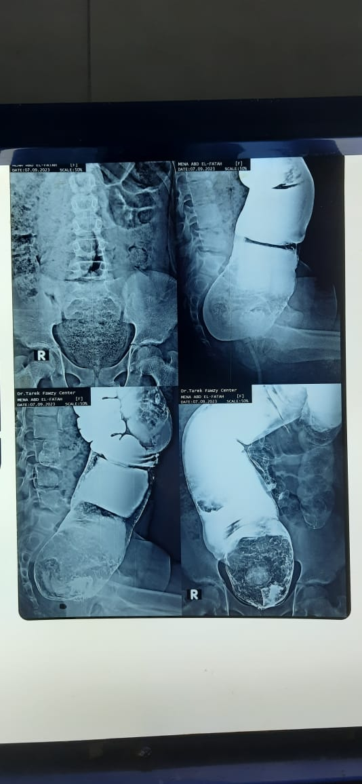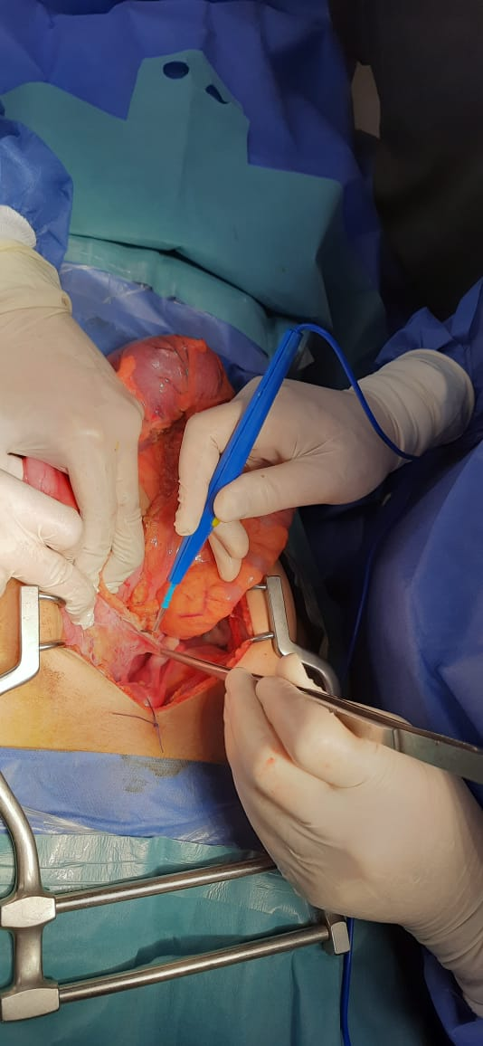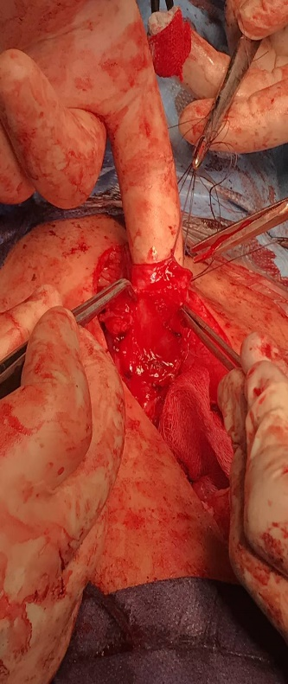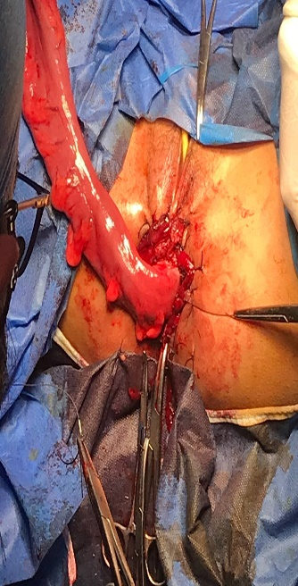
A
B
C
D
Figure 1: (A) Preoperative investigation photo, barium enema showing dilated colon. Intraoperative photo showing (B) dissection around the rectum and hugely dilated colon, (C) small narrow aganglionic segment of the colon, (D) transanal pull through of the colon.

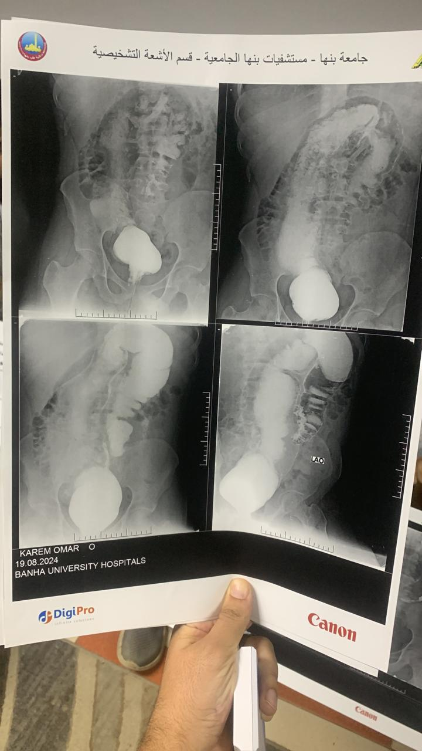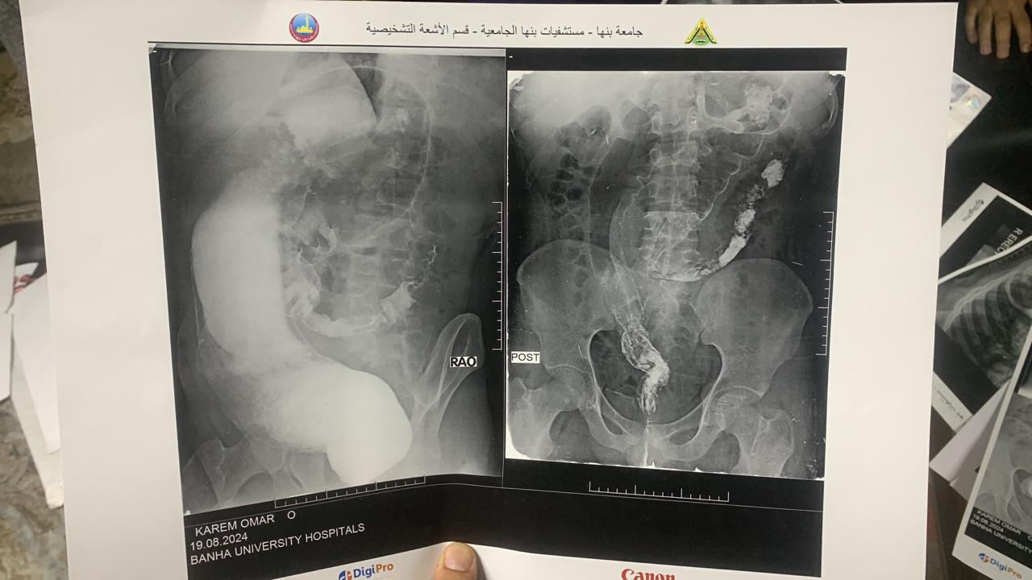
Figure 2: Preoperative investigations, Barium enema showing dilated long segment of colon.

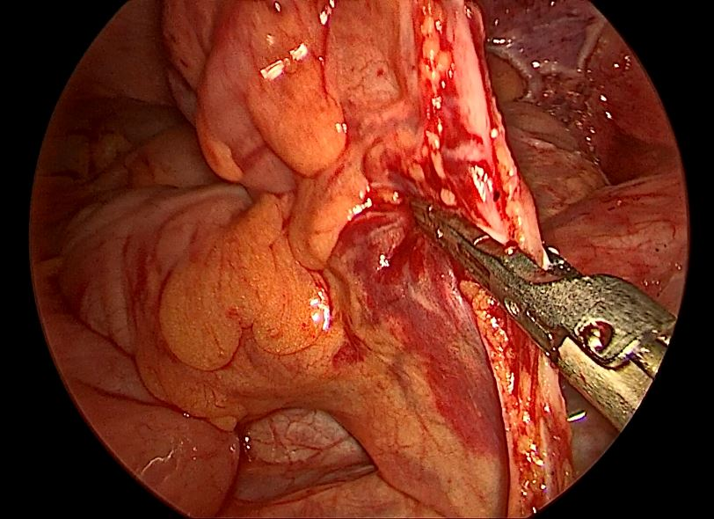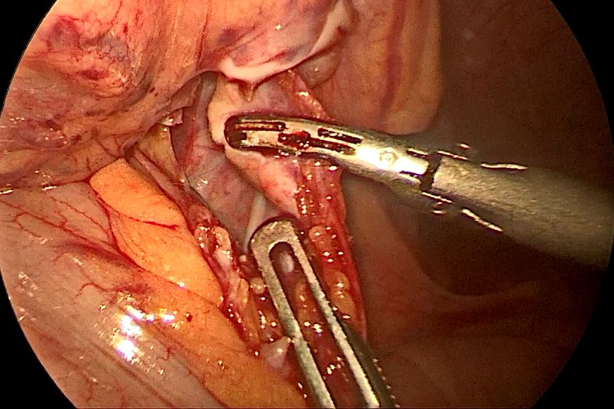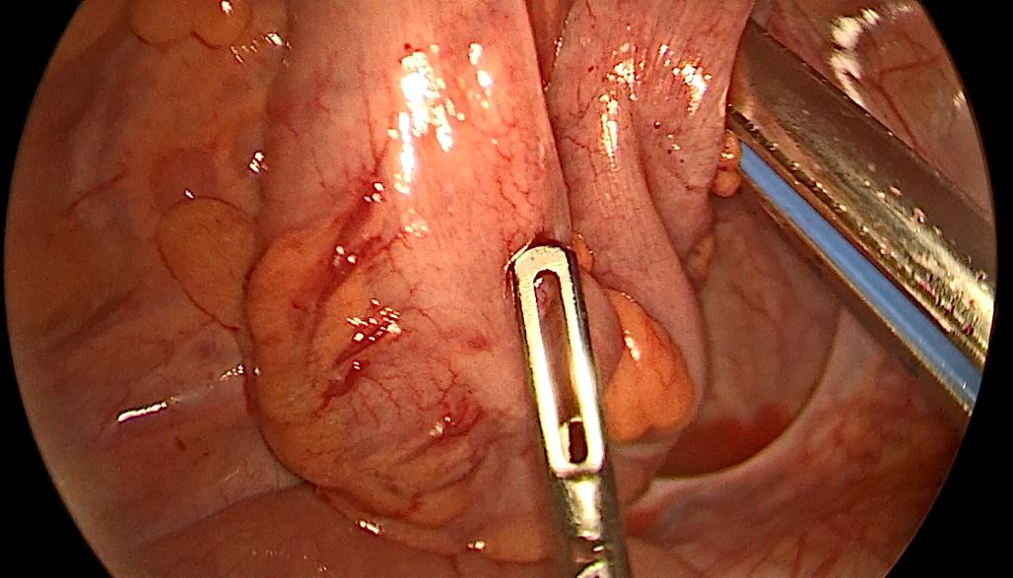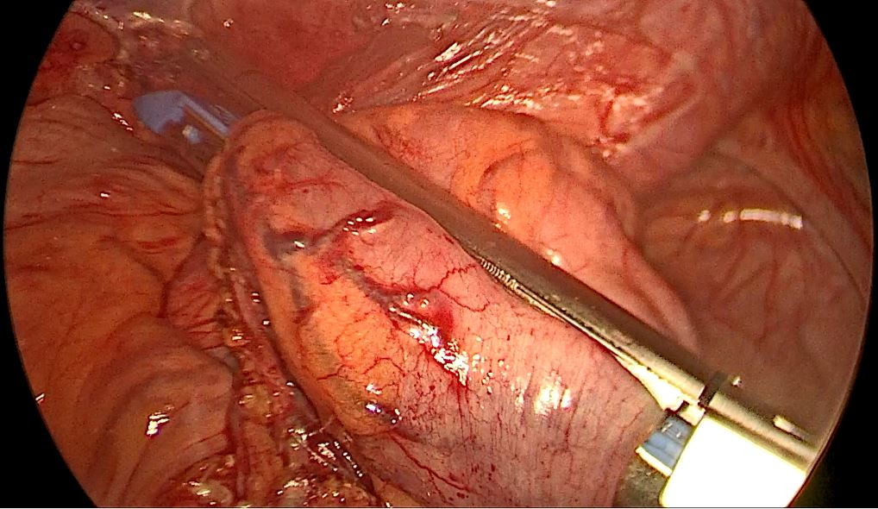
A
A
B
C
Figure 3: Intraoperative photo showing, (A) laparoscopic dissection of the colon, (B) long dissected segment of dilated colon, (C) laparoscopic stapler applied to the colon.

